Shallow copy

When we do clonning of the object than

For primitive data type both the variable and value gets copied in to the new object cloned in the heap memory

For non-primitive data types, for objects like the arrays, strings etc only the reference variables get copied in the new cloned object but the values won’t be copied, instead the copied reference variables in the cloned object will point to the value of the original object

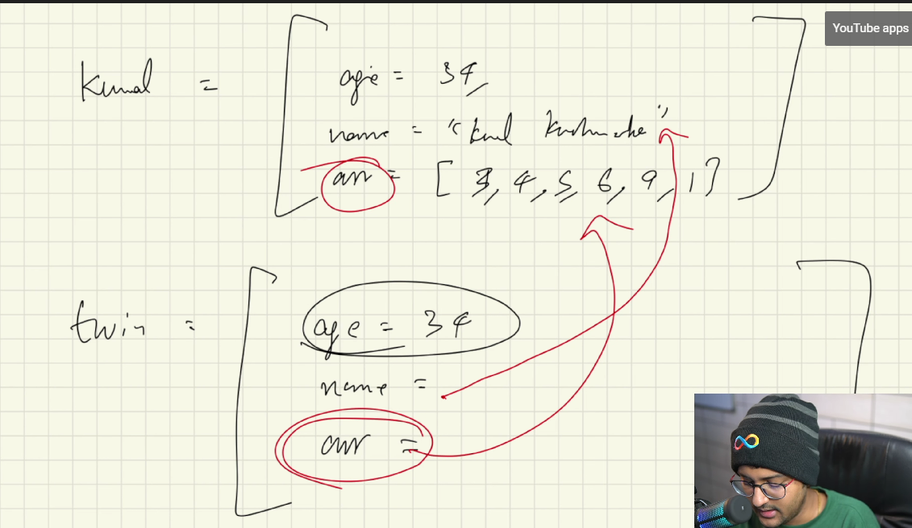

For objects the reference variable is pointing to the value of the same original object

This is not pure copy

So called shallow copy

So, to overcome this we have something called deep copy

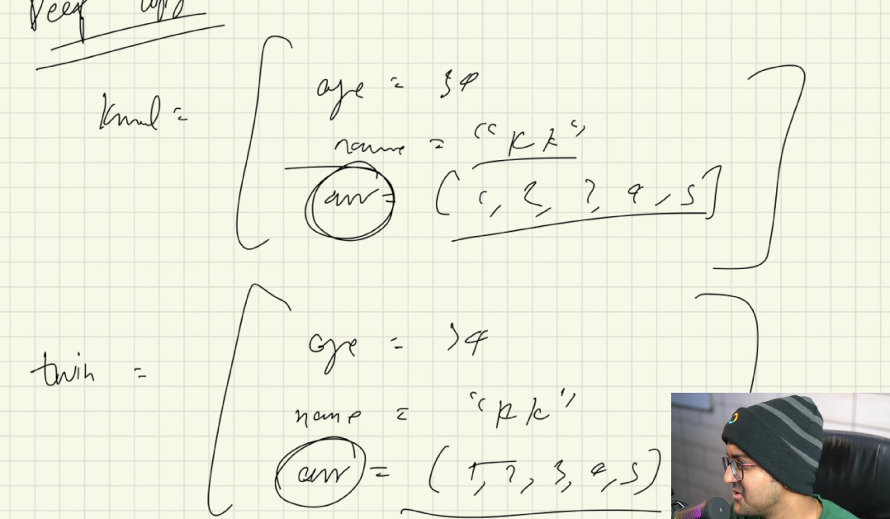

Clone garnie objects bhitra yedi objects haru ( jastai arrays ) haru xan vanne, cloned object bhitra kaa reference variable haru lae original object ko object lai point gardainaa, rather they will point to the objects inside their own cloned object

clone ( ) method by default does the shallow copy

to do deep copy we need to make certain changes inside the clone ( ) method

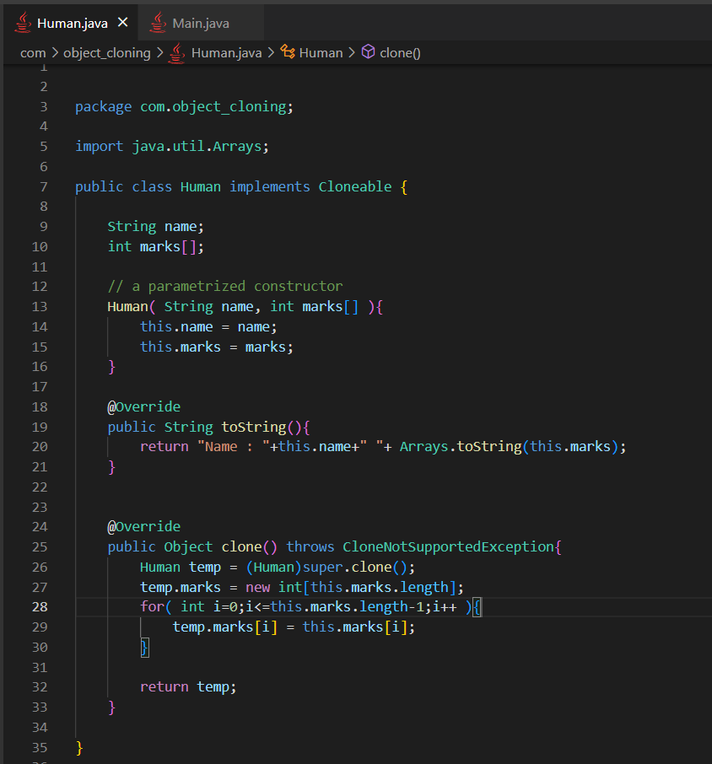

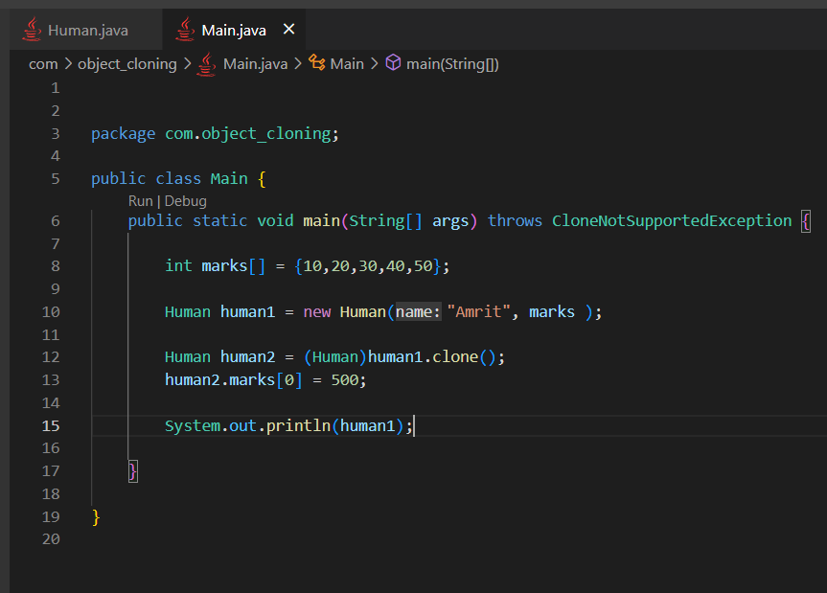

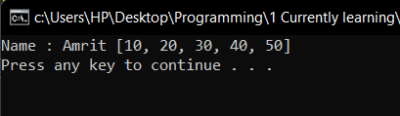 output of human1

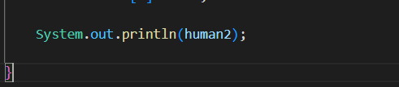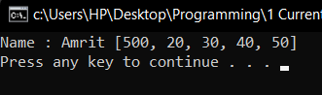 output of human2

If it was shallow copy than the output of human1 would be same as this output of human2